|  |
| --- |
| 新东方在线英语学习 |
| 新概念 3 册 |
| Lesson39 |

Lesson 40 Who’s who

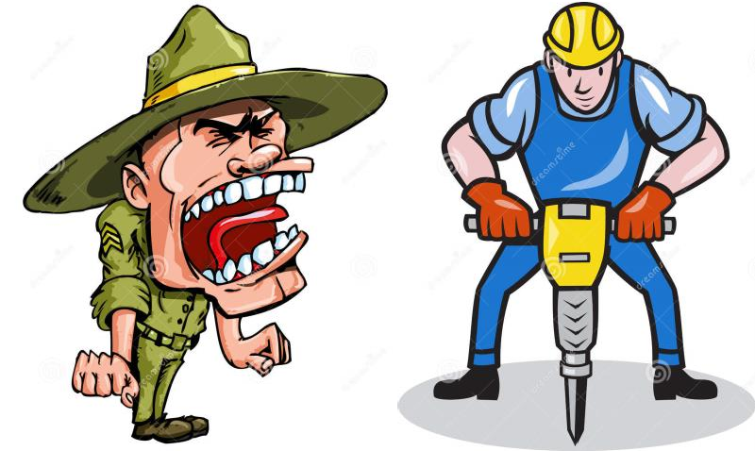

**hoax [həʊks]**

**n. 恶作剧（骗人相信某事）**

hoax n. a kind of practical joke in which someone makes people believe something that is not true

恶作剧（骗人相信某事） play a joke / trick on sb. make a fool of sb.

cheat sb. out of sth.

He cheated the old lady out of her fortune. trick / deceive sb. into doing

I was tricked / deceived into believing his story.

indulge [ɪn'dʌldʒ]

**v. 沉迷于……；尽情享受……**

indulge in …

indulge in bad habits

I indulged in a hot bath / an expensive dinner after a day’s hard work. indulge / spoil / pamper sb.

I don’t agree with indulging children. a spoilt / pampered child

indulgent / self-indulgent indulgence / self-indulgence **advance**

[əd'vɑ:ns] [əd'væns] adj. 提前的（定语）

advance adj. 提前的（定语）

advance party

advance notice / warning / planning advance payment

What a job! Good work, Richard! *I'm so glad you like them so much.* Like them? They represent your best work. *Really?* Absolutely. *Well ... what do you think? Do I have my book?* You do. You do.

There’s a book here. I'll have a contract and an advance payment waiting for you, first thing in the morning.

in advance

Rent must be paid one month in advance. in advance of …

Galileo’s ideas were in advance of the age in which he lived. advanced adj. 高级的, 先进的

advanced technology

an elementary / intermediate / advanced English course elementary / intermediate / advanced English learners **remonstrate ['remənstreɪt] [rɪ'mɑ:nstreɪt]**

v. 抗议，规劝，告诫

remonstrate with sb. (fml.) 向某人抗议

The coach angrily remonstrated with the referee.

Shortly afterwards, four more policemen arrived and remonstrated with the workmen. demonstrate v. 展示, 表明

protest against … 聚众抗议…… complain (to sb.) of / about sth.

Several people complained of cat-like noises at night and a businessman on a fishing trip saw the puma up a tree.

Almost immediately he began to complain about the weather, for even though it was still summer, it rained continually and it was often bitterly cold.

nag sb. to do …

When my wife nagged me to do something about it, I told her that either I would have to buy a new mower or let the grass grow.

pester sb. to do …

From the moment he arrived there, he kept on pestering his doctor to tell him when he would be able to go home.

**ironically [aɪ'rɒnɪklɪ] adv. 讽刺地**ironically / sarcastically

At this, the police pointed out ironically that this would hardly be necessary as the men were already under arrest.

'Perfume, eh?' he asked sarcastically. 'You should have declared that. Perfume is not exempt from import duty.'

ironic / sarcastic

I was almost there when a sarcastic voice below said, 'I don't think the windows need cleaning at this time of the night.'

irony / sarcasm

with heavy irony / sarcasm

'Good of you to arrive on time,' George said, with heavy irony / sarcasm. hint / trace / touch of irony / sarcasm

There was a hint of irony / sarcasm in her voice.

the irony of fate

It's ironic that she became a teacher ―she used to hate school. Ironically, his cold got better on the last day of his holiday.

who’s who 谁是谁（名字、职务等）

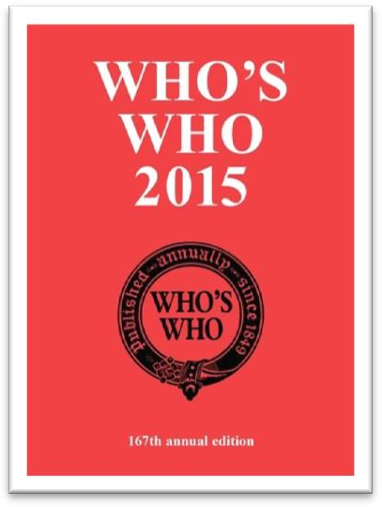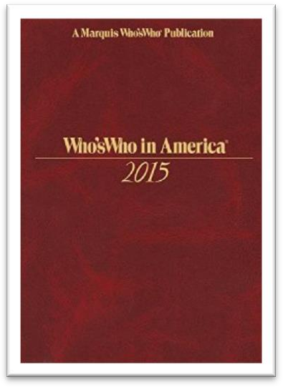You’ll soon get to know who’s who in the company.

which is which

The twins are so alike that I can’t tell which is which.

When Scarlet returned to the farm, the old maidservant began to tell her who married whom, who had what children and so on.

It has never been explained why university students seem to enjoy practical jokes more *than anyone else*.

nobody can explain why …

it has never been explained why …

造句：谁也无法解释玛雅 (Maya) 文明为什么会突然从地球上消失 (vanish)。It has never been explained why Maya civilization vanished from the earth.

I can’t understand / explain why …

Why people are prepared to tolerate a four-hour journey each day for the dubious privilege of living in the country is beyond me.

why … is beyond me

造句：我无法理解Jane 为什么愿意 (be prepared to do) 嫁给这样一个懒汉 (lazy-bones)。Why Jane was prepared to marry such a lazy-bones is beyond me.

It has always been a mystery to me why city dwellers, who appreciate all these things, obstinately pretend that they would prefer to live in the country.

it has always been a mystery to me why …

造句：我一直搞不懂 John 为什么偏要假装 (obstinately pretend) 喜欢古典乐 (classical music)。

It has always been a mystery to me why John obstinately pretends that he would prefer classical music.

She's not sure how she was able to finish so early.

She wasn't able to manage the project well.

She's not sure how to solve the mystery.

She still hasn't heard what was shocking.

M: I was shocked when I heard you'd finished your research project a whole month early. W: How I managed to do it is still a mystery to me.

Q: What does the woman mean?

Answer: (A) She's not sure how she was able to finish so early. People still have different opinions about whether …

Whether the whole universe does so is a moot point at present. whether … is a moot point at present

造句：人们对是否建造更多公路会减少交通堵塞 (traffic congestion) 尚有争议。

Whether building more roads reduces traffic congestion is a moot point at present.

造句：谁也无法解释为什么住在地中海地区的人看似比任何人都更爱吃章鱼 (octopus)。It has never been explained why people who live in the Mediterranean seem to enjoy eating octopus more than anyone else.

specialize in … 专门研究…… specialized adj. 专业的…… specialized knowledge specialized labour / labor

So great is our passion for doing things for ourselves, that we are becoming increasingly less dependent on specialized labour.

a particular type of practical joke practical jokes of a particular type

The more expensive kind of antique shop where rare objects are beautifully displayed in glass cases to keep them free from dust is usually a forbidding place.

Antique shops of the more expensive kind where rare objects are beautifully displayed in glass cases to keep them free from dust are usually forbidding places.

Inviting the fire brigade to put out a non-existent fire is a crude form of deception which no self-respecting student would ever indulge in.

put out = extinguish

put out / extinguish the fire / cigarette / light smother

quench blow out

However, boxing was very crude, for there were no rules and a prize-fighter could be seriously injured or even killed during a match.

form n. a type of sth. form of …

a severe form of cancer different forms of government

no self-respecting … would do sth.

No self-respecting doctor would refuse to treat a sick person. No self-respecting government would yield to terrorists.

造句：考试中作弊是一种很不光彩的行为 (disgraceful behavior)，任何有自尊的学生都不会

去做。

Cheating in examinations is disgraceful behavior which no self-respecting student would ever indulge in.

Students often create funny situations which are amusing to / amuse everyone except the victims.

When a student recently saw two workmen using a pneumatic drill outside his university, he immediately telephoned the police *and* informed them that two students *dressed up as workmen* were tearing up the road with a pneumatic drill.

telephone the police

He told him he had better return it or he would call the police. At first, she decided to go to the police, but …

Mrs. Ramsay was not to inform the police and had to pay ₤1,000. inform sb. of sth.

inform sb. that ... convince sb. of sth. convince sb. that ... remind sb. of sth. remind sb. that ... warn sb. of sth. warn sb. that ... assure sb. of sth. assure sb. that ... dress (sb.) up as ...

She intended to dress up as a ghost ...

He added that a student had dressed up as a policeman … They dressed him up as a gorilla.

disguise sb. as ...

He disguised himself as a dustman. disguised as ...（非谓语）

Alfred the Great acted as his own spy, visiting Danish camps disguised as a minstrel.

... two students disguised as workmen were tearing up the road with a pneumatic drill. tear up sth.

The plumbers tore up the road to lay a new water main. He tore up the letter with anger.

tear

The child’s misery tore my heart. tear sth. in half / two

tear sth. to pieces tear sth. away

In August, she was struck by a very heavy storm during which her rudder was torn away.

As soon as he had hung up, he went over to the workmen and told them *that if a policeman ordered them to go away, they were not to take him seriously*.

as soon as ...

immediately / directly ... the moment ...

on / upon ...

no sooner ... than ...

hardly / barely / scarcely ... when / before ... Immediately / Directly he had hung up, ...

The moment he had hung up, ... On / Upon hanging up, ...

He had no sooner hung up than he went over to ... No sooner *had* he hung up than he went over to ... He had hardly hung up when he went over to ...

Hardly *had* he hung up when he went over to ... hang up

You hang up hurriedly and attend to baby, crockery, etc. put the phone down

slam the phone down get cut off

Eating in a cafeteria.

Buying something in a store.

Talking on the telephone.

Getting money at a bank. M: Did you get cut off?

W: No, they asked me to hang up and try again later. Q: What has the woman been doing?

Answer: (C) Talking on the telephone. He’s seen me! He’s coming over!

She wants to check the weather before deciding.

She has a problem with her hearing.

She’d enjoy coming to dinner another time.

She wants the man to help her with some work. M: Can you come over for dinner tonight?

W: I’m up to my ears in work, so I’ll have to take a rain check. Q: What does the woman mean?

Answer: (C) She’d enjoy coming to dinner another time.

Hello. This is Richard Stewart. My wife, Marilyn Stewart, is a member of your program. I’d like to come to the ten o’clock advanced class this morning. *Oh, fine, fine. Be here a few minutes early. You need to complete some forms before the class.* Thanks. I’m on my way over. Good-bye.

Bye-bye.

be to do (fml.) 的四种用法

1、打算

I’m to see her tomorrow. 2、命令

You’re to be back by 10 o’clock.

No one is to leave the building. 3、能够

How am I to pay such a debt?

We Chinese people are not to be bullied. 4、应该

Such men are to be pitied rather than despised.

Some books are to be tasted, others to be swallowed, and some few to be chewed and digested.

— Francis Bacon

He added that a student had dressed up as a policeman and was playing all sorts of silly jokes on people.

add v. 补充说

Then I added with a smile, ‘It’s a strange mixture I make myself.’

When he received a very rude reply from one of the workmen, he threatened to remove them by force.

At this, the police pointed out ironically that this would hardly be necessary as the men were already under arrest.

However, as the evidence began to accumulate, experts from the Zoo felt obliged to investigate, for the descriptions given by people who claimed to have seen the puma were extraordinarily similar.

It immediately ran away when she saw it, and experts confirmed that a puma will not attack a human being unless it is cornered.

Several people complained of ‘cat-like noises’ at night and a businessman on a fishing trip saw the puma up a tree.

…, as one of them put it ‘ate like kings’. I don’t know how to put it.

The writer stated that Rastus was in safe hands … She explained that Rastus was very dear to her.

He was still mumbling (mumble) something about hospitals at the end of the party when he slipped on a piece of ice and broke his left leg.

When my wife nagged me to do something about it, I told her that either I would have to buy a new mower or let the grass grow.

play a joke / trick on sb.

One night, the gaoler decided to play a joke on his colleague to find out if, after so many performances, he had managed to learn the contents of the letter by heart.

all sorts / kinds / types of sth.

She has to deal with all kinds of complaints.

be thankful / grateful / obliged / indebted to sb. for sth. I’m thankful to you for your help.

I’m much grateful to you for your advice.

I’m deeply obliged to you for your encouragement.

I’m most indebted to you for this piece of advance information. I appreciate your help / it.

I owe you (one).

The student hid in an archway nearby where he could watch and hear everything that went on.

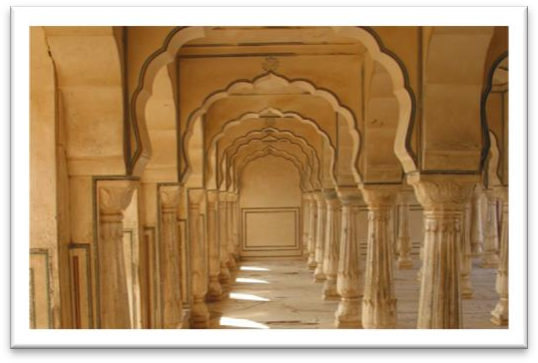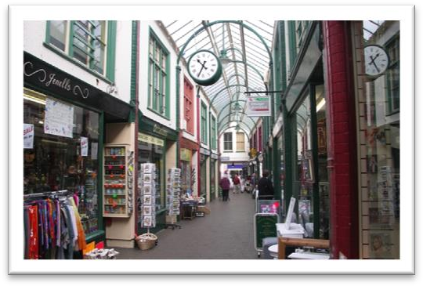Archway arcade

17-Arch Bridge Arch of Triumph

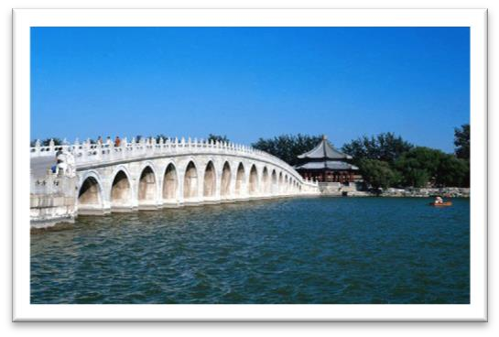 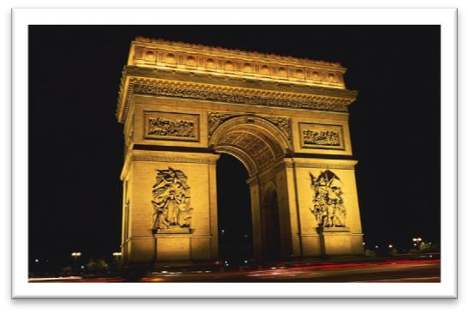

an archway nearby √ a nearby archway √ a near archway ☓

The archway is very near. √ in the near future √

a near relative √

造句：我的暑假是在乡下度过的，在那儿我可以更不受打扰地生活。

The monks prefer winter to summer for they have more privacy.

造句：我的暑假是在乡下度过的，在那儿我可以更不受打扰地生活。 I spent my summer vacation in the country where I had more privacy. sure enough 果然

Sure enough, Rastus arrived punctually at seven o'clock that evening. on the scene / spot 在现场，到现场

Meanwhile, two other actors, Rockwall Slinger and Merlin Greeves, had carried two large food baskets to a shady spot under some trees.

on the spot 当场……, 立即……

He would invent fanciful names on the spot. receive + n. 受到了……; 得到了……; 遭到了……

These young people, who love the peace of mountains, always receive a warm welcome at St. Bernard's monastery.

No creature has received more praise and abuse than the common garden snail.

This exhibition received a great deal of attention in the press, for though the pictures were

supposed to be the work of famous artists, they had in fact been painted by Dickie.

The majority of the patients attending the medical out-patients departments of our hospitals feel that they have not received adequate treatment unless they are able to carry home with them some tangible remedy in the shape of a bottle of medicine, a box of pills, or a small jar of

ointment, … receive support

receive good education receive a heavy blow receive a serious injury

threaten to do 1. 威胁说……；2.有……的危险

We keep trying all four methods, but the sheer volume of rubbish we produce worldwide threatens to overwhelm us.

The workmen told him to do as he pleased and the policeman telephoned for help. please v. 高兴, 乐意

Come whenever you please. lose one’s temper

keep one’s temper

*At this*, the police pointed out ironically that this would hardly be necessary *as the men were already under arrest*.

在英语中，this 和 that 均可前指，但一般只有 this 可以后指。

He threatened to call the police. At this, the police pointed out ironically that …

Finding that he could not remember a word of the letter either, the gaoler replied: 'The light is indeed dim, sire. I must get my glasses.' With this, he hurried off the stage.

To be, or not to be: that is the question.

— Shakespeare Good friends, good books and a sleepy conscience: this is the ideal life.

— Mark Twain

Of all men's miseries the bitterest is this: to know so much and to have control over nothing.

— Herodotus

point out 指出，提醒说

Franz poured scorn on the idea, pointing out that his brother had been killed in action during the war.

be under arrest 被捕

be under + n. 处于某状态

The car is under repair. The castle is under attack.

The subject is under discussion. The matter is under consideration. The patient is under observation. The case is under investigation.

The bridge is under construction. The building is under renovation.

Pretending to speak seriously, one of the workmen asked if he might make a telephone call

*before being taken to the station*.

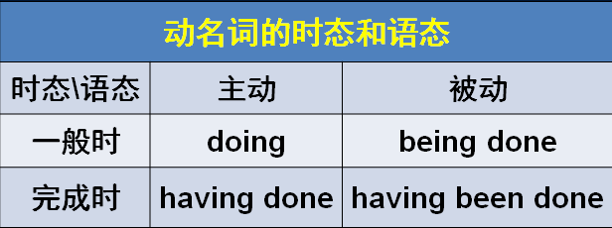

give / grant (sb.) permission refuse / deny (sb.) permission

The police granted him permission and a policeman …

造句：他问老师他是否能打个电话。老师不允许他这么做，于是他只好等到下课。

He asked the teacher if he might make a telephone call. Permission was denied and he had to wait until the class was over.

pay phone / pay station 公共电话

Only when he saw that the man was actually telephoning the police *did* he realize *that they had all been the victims of a hoax*.

复习“only + 状语”位于句首，用部分倒装

Only then *did* he realize that he was mistaken.

Only by working hard *can* we succeed in doing anything.

Only after a baby seal is pushed into the sea by its mother *will* it learn how to swim.

Only when he saw that the man was actually telephoning the police *did* he realize that they had all been the victims of a hoax.